Library Management System
Eastern Connecticut State University
CSC445-01 Software Engineering - Team # 2
Jorge Bautista, Stephen Canavan, Célina L. Pinard, Jack Gustafson

Software Project Management Plan

Document

Version: (1.1) Date: 04/27/2026
SIGNATURE PAGE
The following individuals have reviewed and approved this Software Project Management Plan.

Name Role Signature Date
Stephen Canavan Project Manager stephen canavan 3/13/26

Jorge Bautista Backend Developer Jorge Bautista 3/13/26

Célina L. Pinard Frontend Developer Celina Pinard 3/13/26

Jack Gustafson Database Engineer Jack Gustafson 3/13/26

Change History:
Version Date Description Author
0.1 2/20/26 Initial drafted outline Stephen Canavan
0.2 2/27/26 Revised outline Stephen Canavan
0.3 3/1/26 Preface + Table of Stephen Canavan
Contents + Sec. 1
+ list of fig and tables
0.4 3/2/26 Outline Sec. 6 Jorge Bautista
0.5 3/2/26 Section 2 and 3 Stephen Canavan
0.6 3/6/26 Revised Sec. 6 Jorge Bautista
0.7 3/8/26 Section 4 Stephen Canavan
0.8 3/11/26 Section 5 Stephen Canavan
0.9 3/13/26 Section 6 + 7 Jorge Bautista
1.0 3/13/26 Final Submission Team
1.1 4/27/26 Date Updates Stephen Canavan

Preface:
This document was developed for the CSC445-01 Software Engineering class at Eastern Connecticut State University. It follows the IEEE Std 1058-1998 documentation to meet the IEE Standard for Software Project Management Plans and the requirements provided for this project as part of the class it takes place in. Additionally providing support for structured project execution.
The purpose of this document is to define the management process to which the library management system will be developed. It establishes the roles and responsibilities of each team member, giving clear guidelines to assist efficient and accurate project completion. Scheduling and risk control are also defined in this document to set a realistic timeline to breakdown the work and proper risk control to mitigate issues that may arise. Finally, it governs the development lifecycle of this project as this document evolves along with the project itself making sure each change is documented, and each next step is taken according to plan.
Comparing this document to the Software Requirements Specification (SRS) document. The SRS document is designed to show what the system must do while this document (SPMP) defines how the team will manage the development. This important distinction allows for proper understanding of how to reference each document throughout the development process.
This document is intended for development team members, the course instructor, and any potential project stakeholders. It acts as a formal agreement between the team members for the management process and the expectation of the project lifecycle.
Table of Contents:

1. Overview 6
1.1. Project Summary 6
1.1.1. Purpose, Scope, Objectives 6
1.1.2. Assumptions and Constraints 7
1.1.3. Project Deliverables 7
1.1.4. Schedule and Budget Summary 8
1.2 Evolution of the Plan 8
2. References 9
3. Definitions 9
4. Project Organization 10
4.1. External Interfaces 10
4.2. Internal Structure 11
4.3. Roles and Responsibilities 12
5. Managerial Process Plans 13
5.1. Start-up plan 13
5.1.1. Estimation Plan 13
5.1.2. Staffing Plan 13
5.1.3. Resource Acquisition Plan 14
5.1.4. Project Staff Training Plan 14
5.2. Work Plan 14
5.2.1. Work Activities 14
5.2.2. Schedule Allocation 15
5.2.3. Resource Allocation 15
5.2.4. Budget Allocation 15
5.3. Control Plan 15
5.3.1. Requirements Control Plan 15
5.3.2. Schedule Control Plan 16
5.3.3. Budget Control Plan 16
5.3.4. Quality Control Plan 16
5.3.5. Reporting Plan 16
5.3.6. Metrics Collection Plan 17
5.4. Risk Management Plan 17
5.5. Closeout Plan 18
6. Technical Process Plans 18
6.1. Process Model 18
6.2. Methods, Tools, and Techniques 19
6.3. Infrastructure Plan 19
6.4. Product Acceptance Plan 20
7. Support Process Plans 20
7.1. Configuration Management Plan 20
7.2. Verification and Validation Plan 20
7.3. Documentation Plan 20
7.4. Quality Assurance Plan 21
7.5. Reviews and Audits 21
7.6. Problem Resolution Plan 21
7.7. Subcontractor Management Plan* Not really applicable 21
7.8. Process Improvement Plan 21
8. Additional Plans 21

List of Tables:
Table 1. Schedule Summary 8
Table 2. Resource Summary 8
Table 3. Definitions 10
Table 4. Roles and Responsibility Matrix 12
Table 5. Work Activities 14

List of Figures:
Figure 1. External Interface 11
Figure 2. Iterative Development 18

Overview

Project Summary

Purpose, Scope, Objectives
This project exists to fulfill the requirements of the CSC-445-01 Software Engineering class. It aims to design and implement a library management system to the specifications provided within the assignment instructions. The Software Project Management Plan conforms to IEEE Std 1058-1998. The Software Requirements Specification conforms to IEEE Std 830-1998, and the Software Design Description conforms to IEEE Std 1016-2009.
The goal of this project is to solve the problem of an inefficient physical library management system. Manually tracking books is inefficient and can lead to human error. A good library management system needs to have a centralized catalog, a borrower tracking system, and accurate late fee management.
Defining the scope of the project elements that will be in the system include book catalog management, member registration, borrow and return functionality, administrative controls, and a search functionality within the catalog of offered books. It is important to note that this project specifically will exclude any real payment processing, integration with any external university system, mobile app development and deployment, or any production deployment beyond the course environment.
The objectives that this project will complete include
- Deliver a fully functional Library Management system by May 2026
- Achieve full requirements traceability
- Implementation of configuration management and version control
- Complete the project within the semester schedule meeting the deadlines
The official product requirements are defined within the SRS document for the Library Management System.

Assumptions and Constraints
Assumptions:
- All team members will remain enrolled in the class for the full semester
- Required tools (GitHub, VSCode) will remain available
- No major project requirement changes will take place after project approval
- The development and class environment will remain stable
Constraints:
- Short timeframe with fast approaching deadline
- Lack of funding
- Limited team size (4 members)
- Academic grading deadlines
- Software stack used is chosen early in the process
- Must comply with IEEE standards

Project Deliverables
The following items will be delivered as part of this project:
- Software Requirements Specification (SRS)
- Software Project Management Plan (SPMP)
- System Design Documentation
- Forked Source Code Repository via GitHub
- Logs and Journals
- Library Management System Executable
- Configuration files
- Installation and User Guide
- Reference Materials
- Final Project Presentation
All deliverables will be submitted via blackboard at or before the scheduled deadline.

Schedule and Budget Summary
This section provides a high-level summary of the project schedule and estimated allocation of resources.
Table 1. Schedule Summary
Individual Project Step | Project Timeline
Requirements | March 13, 2026
Design | April 8, 2026
Implementation | April 20, 2026
Testing | May 1, 2026
Final Submission | May 8, 2026

This project does not include any direct financial expenses. Budget considerations for this project are measured using estimated labor hours across the semester. With all four team members, the project is estimated to require around 200-250 total working hours.
Table 2. Resource Summary
Individual Project Steps | Estimated Total Hours
Requirements | 32
Design | 60
Implementation | 100
Testing | 40
Total | 232

Evolution of the Plan
The initial version of this document (1.0) will be submitted on March 13, 2026. Updates to this document may occur at major milestones of the project including the design, the implementation, or even during the testing phase. All updates will be recorded under the change history section of this document.
The change control process will proceed as described here. First the change will be proposed by a team member. This change will then immediately be reviewed by the project manager. From there the change will be approved via team consensus. The change will take place and then the version of this document will be updated accordingly. This updated version of the document will then be pushed to the shared Git repository for transparency.
The configuration management of this project will take place by storing all relevant documents in a shared Git repository specifically this SPMP. Each document will be controlled via its version tags noting any changes that take place. Only approved changes will be pushed into the main branch of the repository. This will allow access seamlessly for all members and proper configuration control as required under the IEEE standard.

References
[1] IEEE Standard for Software Project Management Plans, IEEE Std 1058-1998, Institute of Electrical and Electronics Engineers, 1998.
[2] IEEE Recommended Practice for Software Requirements Specifications, IEEE Std 830-1998, Institute of Electrical and Electronics Engineers, 1998.
[3] IEEE Standard for Software Design Descriptions, IEEE Std 1016-2009, Institute of Electrical and Electronics Engineers, 2009.
[4] Software Requirements Specification (SRS) for the Online Library Management System, Version 1.0, March 2026, CSC445 – Software Engineering, Eastern Connecticut State University.
[5] Software Design Description (SDD) for the Online Library Management System, Version 1.0, Spring 2026, CSC445 – Software Engineering, Eastern Connecticut State University.
[6] CSC 445 Project Description Document, Spring 2026, Eastern Connecticut State University.
This SPMP complies with the IEEE Std 1058-1998 structure with minor adjustments to reflect the academic context and constraints of this project that take place within a single semester.

Definitions
This section defines the terms and acronyms that are required for understanding this Software Project Management Plan.
Table 3. Definitions
Term | Definition
SPMP | Software Project Management Plan
SRS | Software Requirements Specification
SDD | Software Design Description
IEEE | Institute of Electrical and Electronics Engineers
IEEE 1058 | IEEE Standard for Software Project Management Plans (IEEE Std 1058-1998)
IEEE 830 | IEEE Recommended Practice for Software Requirements Specifications (IEEE Std 830-1998)
IEEE 1016 | IEEE Standard for Software Design Descriptions (IEEE Std 1016-2009)
WBS | Work Breakdown Structure. Hierarchical breakdown of the project tasks
Configuration Management | The Process of controlling changes to the project documents and software
Change Control | The formal process that is used to propose, review, approve, and document modifications
Milestone | A significant event or point of completion in the project schedule
Deliverable | A work product produced for the project

Project Organization

External Interfaces
This project is conducted within the environment of CSC445-01 Software Engineering at Eastern Connecticut State University. The development team, Team #2, is responsible for the design and implementation of the Library Management System. The course instructor, Dr. Gao, takes the role as the project sponsor, providing requirements clarification, feedback and oversight spanning the duration of the project lifecycle.
The client or acquiring organization for this project is a hypothetical library organization that is in need for a new digital library management system with the need for managing a catalog, borrowing and returning, reservation management, and user and administration accounts. The system is designed to support library staff and patrons by providing functionality in all the above-mentioned areas.
External stakeholders that would interact with the system would include library patrons and staff. Patrons interact with the system by using the catalog search, borrowing, and account management features. Library staff would use the system to perform administrative actions like inventory management or late fee enforcement. The course instructor additionally acts as an external authority who is responsible for evaluating the deliverables and ensuring the project adheres to the given requirements and documentation standards.
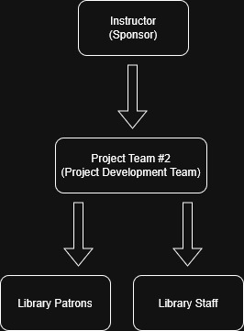
Figure 1. External Interface

Internal Structure
The project team for this Library Management System is organized into a role-based structure that allows for coordinating system design, implementation, and data management. The team structure breaks down into a project manager who also contributes to full-stack development, a backend developer, a frontend developer, and a database engineer. This structure allows for the technical responsibilities of the project to be distributed across multiple functional areas while maintaining clear communication and coordination between the team members.
The project manager, Stephen Canavan, takes on the responsibility of project coordination, planning, and scheduling to ensure that the deliverables are completed by the project milestone deadlines. Along with the management responsibilities, the project manager also takes a role in full-stack development where it is imperative to take on areas that are too large or challenging for a single developer or architect. This role allows for collaboration across the team ensuring all the components of the system are properly integrated together.
Backend development is spearheaded by Jorge Bautista, who is tasked with implementing the server-side logic, application programming interfaces (APIs), and the business rules that are required for the system’s operation. Frontend development activities are taken on by Célina Pinard, who is responsible for creating and implementing the user interface and ensuring that the system functionality is accessible through a responsive user-friendly web interface. Database engineering responsibilities are assigned to Jack Gustafson, who aims to design and manage the system’s data models, database schema, and the data integrity mechanisms.
The supporting project process like configuration management, documentation, verification activities, and testing coordination are to be conducted collaboratively between all team members with clear oversight from the project manager to maintain consistency between the system requirements, project documentation, and implementation.

Roles and Responsibilities
This section defines the major responsibilities and work activities involved with the development of the Library Management System. It identifies the project team members responsible for each activity. The responsibilities are distributed based on the functional roles assigned within the development team. This ensures each major component of the system including but not limited to data management, application logic, and user interface is developed and maintained by a team member with the appropriate role.
The following responsibility matrix summarizes the responsibilities associated with each project role.
Table 4. Roles and Responsibility Matrix
Project Activity | Stephen (Project Manager/Full Stack) | Jorge (Backend Developer) | Célina (Frontend Developer) | Jack (Database Engineer)
Project planning and milestone tracking | x
Requirements review and validation | x | x | x | x
System Architecture design | x | x |  | x
Backend service development | x | x
Frontend user interface development | x |  | x
Database Schema design |  |  |  | x
API integration | x | x | x
Data management & controls |  |  |  | x
System integration | x | x | x | x
Testing & verification | x | x | x | x
Document preparation | x | x | x | x
Configuration management | x

Managerial Process Plans

Start-up plan
The project start-up plan covers the activities that are required to prepare and organize the team members before beginning system development. This includes the project effort estimation plan, the staffing plan, the resource acquisition plan, and the project staff training plan.

Estimation Plan
To establish an estimation plan on the effort it would take the team members the project requirements were reviewed. The development tasks for this project were then divided into phases to structure the work in a manageable manner. Based on the scale of each phase the estimated effort hours for each person was calculated and then added together to get a total effort estimation. These estimates were aligned with the project milestones provided by course structure to ensure each deadline is met. All estimates are subject to revision if necessary.

Staffing Plan
The project is staffed by four team members. Each staff member was given a role based on their technical background and expertise along with what the necessity of the project needs. This staffing plan supports the system architecture to ensure that all elements of development are successfully completed. Detailed role descriptions and responsibilities assignments are clearly defined in Section 4.3 under the responsibilities matrix.

Resource Acquisition Plan
The required development resources for this project include development machines, a version control repository via GitHub, VS Code as an IDE, Microsoft Word for documentation purposes, and Oracle DB used for database. The key tools for this project will be the personal development machines which are required for the use of all the remaining tools. VS Code repository for its IDE capability and Microsoft Word for its documentation ability. Additionally, Oracle DB will be imperative to the project as it hosts the database for this project. All these resources already exist, free-to-use, and are currently accessible.

Project Staff Training Plan
Training considerations for this project are limited. The existing skills of all the current team members encapsulate all the requirements of this project. Any knowledge gaps that are found among the project and the team members will be handled by using external resources to learn the required skills to complete the task that the knowledge gap exists in. While some knowledge gaps may exist extensive training on specific programs is not required for this course specific project.

Work Plan
This work plan describes how the project tasks are organized and how they are executed throughout the project development lifecycle. It breaks down work activities, schedule allocation, resource assignments, and the estimated effort for each phase.

Work Activities
Work activities are organized into separate development phases. These include the requirements, design, implementation, testing, and delivery of the system. Dividing the work into these development phases helps organize the development of the system. Project milestones are key points that clearly define what work activities must be done within a certain time frame. Across these development phases all the team members collaborate to ensure adequate project completion.
Table 5. Work Activities
Phase | Activities
Requirements | Develop the SRS
Design | Architecture and database design
Implementation | Coding system components
Testing | Debugging and validation
Finalization | Documentation and submission

Schedule Allocation
The project schedule is based upon the course milestones that have been set by the course instructor. The deadlines of these course milestones aid in monitoring progress of the full project. While most tasks will be completed before the next one is started there may be task overlap, for example the SRS or SPMP may need to be updated during the design phase if one requirement is discovered to have a better alternative. See Table 1 for a schedule summary.

Resource Allocation
Tasks are assigned based on roles and expertise. Each development task is distributed among the team members with a relatively equal or fair amount of work distributed between them in terms of work hours. Integration and testing, however, will require full team participation and will not be done individually. See Table 4 for the roles and responsibilities matrix which gives a break down of how each team member will complete each task.

Budget Allocation
There is no monetary budget for this project, instead the budget is calculated using total work hours combined among the team members. It is important to assign each team member a fair amount of work to make sure that the allocation of work hours is evenly distributed. The total work hours for each team member was estimated based on their task and then all the team members totals were added together to get the total project work hours. See Table 2 for a resource summary of how each project phase is broken down and added together.

Control Plan
The Control Plan describes the ways project progress is monitored and allows alignment to be maintained alongside the project objectives. This includes plans for requirements control, schedule control, budget control, quality control, reporting, and metrics collection.

Requirements Control Plan
The requirements for this project are stated and defined in the SRS document. To prevent the rapid and uncontrolled changing of requirements, a control plan is implemented where each new requirement must be proposed then reviewed by the project manager, then all the team members must approve it from there before it is updated in the SRS and the document is then versioned for control. It is important to conduct an impact analysis of each new requirement as throwing in a new requirement may cause increasing scope or hope creep making the project not feasible within the static timeline. Traceability is another important aspect of requirements as it is important to know who came up with the requirements to have proper documentation.

Schedule Control Plan
The schedule control purpose is to track whether the team is on schedule based on the course milestones. The progress of this project is tracked based upon milestone completion. Every time a key milestone is reached the progress of the project will be updated. If delays occur where project milestones are pushed back the team adjusts the tasks and the deadlines of the tasks to fit the new deadline. During team meetings that discuss the schedule the actual progress the team has made compared to the planned schedule and how to proceed based on the information will be determined.

Budget Control Plan
The budget is measured not monetarily but instead is measured based on individual and collective work hours. Tracking the amount of time each task takes to complete will allow for comparison between estimated work hours and actual work hours. This will be a guide for future tasks as if one task takes significantly less time than anticipated and the remaining work hours can be allocated to a different task. If the workload is determined to be to large for a team member and the work hours that member is putting in are significantly more than planned, the work load will be adjusted by adding multiple team members to that task. See table 2 for a resource summary which is also a breakdown of work hours.

Quality Control Plan
To ensure the system works correctly and is designed to the desired quality multiple tasks will take place to ensure the project meets the standard. Code review will be done of each coding portion of the project to ensure that proper software engineering best practices are being used. Testing will take place once the code is completed to ensure the system works as intended in a variety of different ways to fix any bugs that may appear. Requirements validation will also be used to ensure that each requirement is achievable and implementable based on the resources available.

Reporting Plan
The team will report progress on what they have done in their project work journal. This personal journal will be used to keep track of every task done and the time required to do it along with any issues encountered. The team will communicate progress with each other particularly before committing to the main branch of the GitHub repository. Document updates including updates to the SRS or SPMP will be communicated between the team members before the implementation is made the document version is incremented. Each project milestone will include submitting and reporting the progress the project team has made to the course instructor.

Metrics Collection Plan
The data metrics that will be collected throughout this project will include number of tasks completed, number of bugs found, milestones completed, and number of commits made to the repository by each user. These metrics will help monitor the progress the team is making on an individual level noting any challenging sections based on bug reporting statistics. Additionally individual productivity will be able to be evaluated based on number of commits and tasks completed. After the completion of each key project milestone the metrics will be evaluated by the project manager and then dispersed to the team members. This will allow for any productivity challenges to be addressed and success to be praised.

Risk Management Plan
Throughout this project it is critical to identify risks early and monitor them throughout the duration of the project. Potential risks that have been identified include schedule delays, technical challenges with software or hardware, communication problems with team members, requirements misinterpretation, and a team member dropping the class. These risks will continue to be monitored while new risks may be identified and monitored as well.
Risks are handled in multiple ways. Early design planning is key to combat schedule delays as staying proactive with the work will help mitigate the impact of the delay. Team collaboration will be especially important as frequent contact will help prevent miscommunication. Task redistribution will help push back against any technical issues a single member may experience. Additionally, milestone tracking will be imperative to understand where the team is within the project and help prevent against requirement misunderstanding.
Risks will be monitored and tracked to ensure they are properly managed. Through team meetings the team can identify any new risks that may have been discovered and discuss how to better manage any persisting risks. Milestone review will be another important task as this will track the progression of the project and any risks that are carrying over to the next project phase and any risks being left behind. Finally, project manager oversight will be used to oversee all the project phases and tasks and note any risk that may be invisible to the members working on specific project phases.

Closeout Plan
When the project ends the team will have completed all the deliverables required by the course for this project. The final software product will be submitted to the course instructor along with all the configuration files, associated documentation, installation guide, user guide, reference material, and all journals or logs. This will all be wrapped up with the final project presentation done for this CSC-445-01 Software Engineering class.
After completion the GitHub repository will be archived. All the documentation for this project will be preserved and archived. Finally, the team will reflect on the project experience and identify things that went well and things that went poorly and how the project team can incorporate what was learned into future professional careers.

Technical Process Plans

Process Model
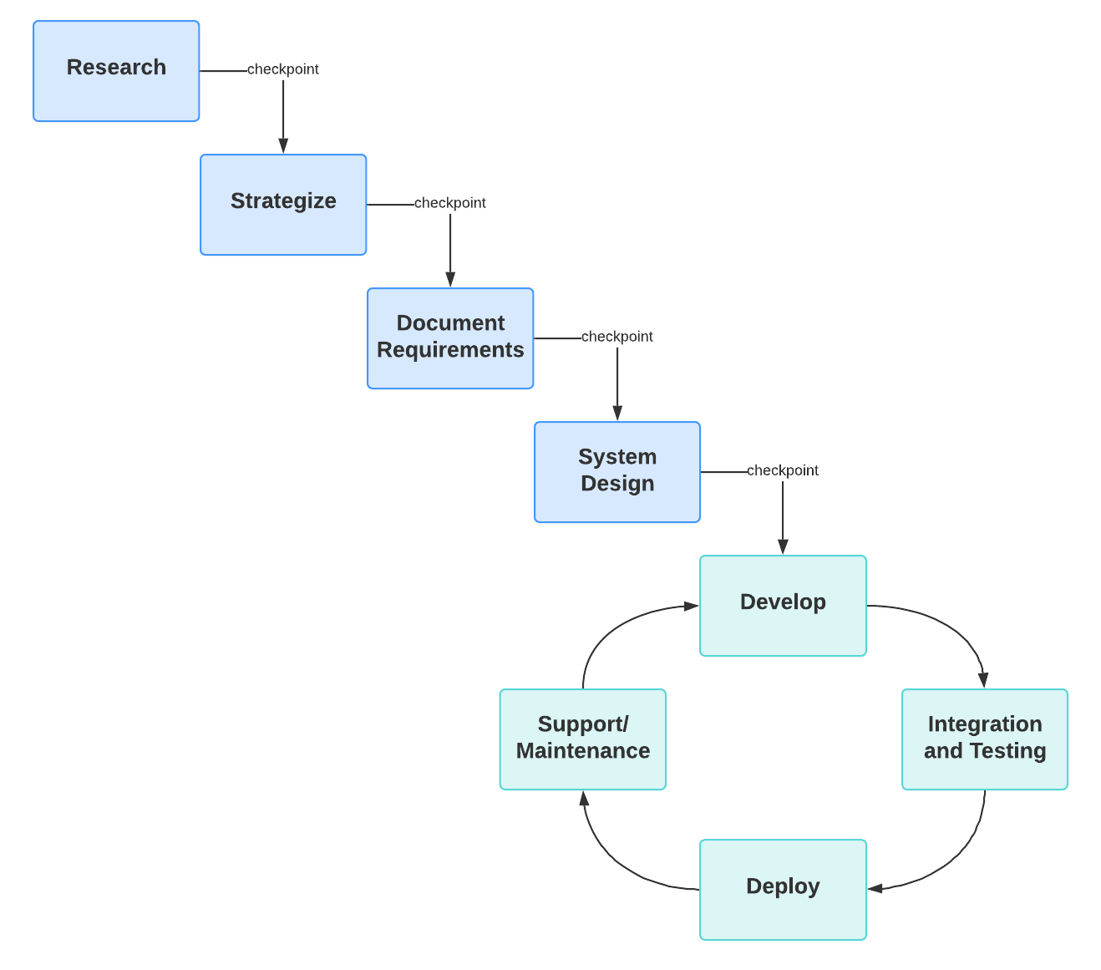
Figure 2. Iterative Development
This project will utilize a hybrid Agile-Iterative process model to incorporate its flexible, rapid development lifecycle. Specifically, the project team will incorporate two phases into development to ensure technical accuracy and efficiency within the short timeline provided.
Phase 1 will incorporate an iterative process model for foundational steps including research, strategizing and planning, requirements engineering, and system design. This phase will handle creating and refining important documentation. It will also work to define the technical stack and finalize the library’s database requirements. The project team utilizes versioning and formal checkpoints to ensure that all team members are aligned before advancing coding. This approach is crucial to ensure that all requirements, research, and design have concluded to best prepare for the second phase.
Phase 2 will be using the Agile methodology to develop, test, deploy, and maintain the software. This shift in methodologies will allow the team to work in parallel cycles to develop the software as efficiently as possible. By using this loop, the project team can both code and perform verification/validation continuously allowing for faster turnaround times. This phase will conclude with packaging and deploying the Library Management system by May 8th , 2026.

Methods, Tools, and Techniques
The Library Management System will leverage a multi-tiered system comprising three main sections.
For the frontend, Céline Pinard will utilize a standard web stack composed of HTML and CSS for site structure and style. JavaScript or TypeScript will be used to handle user interactions and communication with the backend to display search results, manage user views, and perform other actions. Jorge Bautista will lead the backend development, using Node.js.
The system’s data layer will primarily be managed by Jack Gustafson, through the use of a PostgreSQL database to store metadata, records, transaction history, and more.
To facilitate team collaboration and version control, team members will use a shared GitHub repository. Development will take place within Visual Studio Code. Furthermore, the team will incorporate artificial intelligence tools as aids for brainstorming, drafting, logic, and debugging. All AI assistance and usage will be in accordance with our AI use statement.

Infrastructure Plan
The project’s architecture will rely on personal machines and open software to adhere to our budget of $0. Personal machines will function as our primary work environment, with local instances of the Node.js backend, PostgreSQL databases, and VSCode. GitHub will be used as a cloud-based repository for all source code, configuration files, and documentation to ensure all team members will have access to the project regardless of device or location. Communication and team coordination will be performed through iMessage, and group calls if needed. Each team member will be responsible for the stability and security of their personal machine.

Product Acceptance Plan
Acceptance of this project will be determined by the system’s ability to satisfy the requirements established in the Software Requirements Specification (SRS). The project manager and development team will perform a final review to ensure that all features perform as defined in the SRS and SPMP before the final submission. All deliverables will be submitted via Blackboard by May 8th, 2026.
- Support Process Plans

Configuration Management Plan
The project uses GitHub to identify configurations, handle version control, and provide all source code and IEEE-mandated documentation. The team will use branching during development and will merge code into the main repository following peer review and approval by the project manager. Each major version of the SPMP and SRS is identified by unique version tags, providing a clear change of history and ensuring that all team members are working from the most recent, approved project specifications.

Verification and Validation Plan
Verification and validation processes will be conducted throughout the lifecycle of this project to ensure the system is built correctly and fulfills project requirements. Verification will be performed through peer code reviews and reviewing documentation against IEEE standards. Validation will be performed through testing phases by all members to ensure that the system functions as intended.

Documentation Plan
The documentation plan identifies the specific documents required for this project, including the SRS, SPMP, SDD, and final report. All members collaborate on the preparation and review of these documents. The project manager additionally provides oversight for quality and consistency in accordance with IEEE standards. Additional materials such as work journals are maintained by the individual in preparation to be submitted at the end of the project.

Quality Assurance Plan
Quality assurance procedures are implemented in this project to ensure software integrity. Regular audits of the GitHub repository will review quality and provide feedback to members through peer reviews. Any AI-assisted code is thoroughly reviewed, validated, and understood by the team before integration. Success is measured by the system’s ability to pass verification tests and the team’s adherence with documentation and project requirements.

Reviews and Audits
The team conducts regular internal reviews to monitor project progress and adhere to the schedule and milestones. Formal external reviews are conducted by the instructor at milestones for the requirements, design, and final implementation phases. These audits serve as checkpoints to ensure that the project is on track, and to correct any errors before advancing.

Problem Resolution Plan
Bugs and documentation errors found are tracked and resolved through the GitHub Issues feature. This will allow the team to report and assign problems to the appropriate team member. Additionally, issues are brought up during team meetings, and effort is documented in individual work journals.

Subcontractor Management Plan* Not really applicable
This section is not applicable to the current project. All work and development are performed internally by the four team members of Team #2.

Process Improvement Plan
The team periodically assesses the project to identify areas for improvement and improve efficiency. If productivity challenges are identified, some of the workload and tasks are redistributed among team members to maintain the project’s momentum. Additionally, the project manager will take on additional development responsibilities to assist team members who are struggling. This redistribution of tasks will ensure that the project is aligned with established deadlines.

Additional Plans
In accordance with the project guidelines, the team will utilize AI-assisted tools for brainstorming, drafting, and debugging. To ensure integrity and accuracy, the team remains fully responsible for all submitted work and will not allow AI to replace human design rationale or team collaboration. Deliverables submitted to the instructor will include a AI Usage Statement describing the usage of AI in this project.

